**MIHLE**

**MADLAVU**

**ST10472621**

**WEB DEVELOPMENT**

**ICE TASK 4**



GAME

Contents

1. Organisation Overview: 3

Name: 3

History: 3

Mission & Vision 3

Target Audience: 3

2. Website Goals & KPIs: 3

3. Current Website Analysis: 3

4. Proposed Features: 4

5. Design Aesthetic: 4

6. Technical Requirements: 4

7. Timeline with Milestones: 5

8. Budget: 5

Site Map: 6

9. References: 7

# 1. Organisation Overview:

Name: Game Stores South Africa

History: Established in 1970 in Durban, Game has grown into one of Southern Africa’s largest discount retailers, operating over 100 stores in 12 African countries (Massmart, 2025).

Mission & Vision: Game aims to provide customers with a wide range of products at competitive prices, offering a one-stop shopping experience for household, electronics, groceries, and lifestyle goods (Game, 2025).

Target Audience: Middle-income families, bargain hunters, and tech-savvy consumers seeking both affordability and variety.

# 2. Website Goals & KPIs:

The primary goal is to enhance Game’s e-commerce platform to:

Increase online sales by 15% within 12 months.

Reduce website bounce rate to below 40%.

Improve average order value by 10% through upselling and cross-selling (BigCommerce, n.d.).

Expand loyalty programme sign-ups by 20%.

# 3. Current Website Analysis:

Game currently operates an e-commerce website with an extensive product catalogue and online ordering system. Strengths include diverse product categories, promotions, and delivery/pick-up options. Weaknesses include slow page load times and limited personalisation (Shopify, 2025). Competitors such as Makro and Takealot offer more advanced filtering and tailored recommendations.

# 4. Proposed Features:

Homepage: Dynamic hero banner with rotating promotions, personalised recommendations.

Product Pages: High-resolution images, detailed specs, customer reviews.

Checkout: One-page checkout with multiple payment options, including PayJustNow and PayFlex.

Customer Support: Live chat, FAQ, and warranty claim portal.

Extras: Store locator, loyalty card integration, and “Deal of the Day” section.

# 5. Design Aesthetic:

Colour Scheme: Brand’s existing magenta and grey palette for consistency.

Typography: Sans-serif fonts for clarity and modernity.

Layout: Grid-based product displays, minimal clutter, responsive design.

Wireframes: Homepage → Product category → Product detail → Checkout.

# 6. Technical Requirements:

Hosting: Cloud-based e-commerce hosting with 99.9% uptime.

Domain: Existing domain maintained.

Stack: HTML5, CSS3, JavaScript (React for UI), WooCommerce or Magento backend.

Security: SSL certificate, PCI-DSS compliance, data encryption.

# 7. Timeline with Milestones:

| Week | Milestone |
| --- | --- |

|  |  |
| --- | --- |
| 1 | Requirements gathering, sitemap |

|  |  |
| --- | --- |
| 2 | Wireframes & design mock-ups |

|  |  |
| --- | --- |
| 3–4 | Development of homepage & product pages |

|  |  |
| --- | --- |
| 5 | Checkout integration, payment gateways |

|  |  |  |
| --- | --- | --- |
| 6 |  | Testing & bug fixing |

|  |  |
| --- | --- |
| 7 | Launch & post-launch monitoring |

# 8. Budget:

Web design & development: R 15 000

Hosting & SSL: R 2 500/year

Maintenance & updates: R 12 000/year

Marketing integration: R 8 000

# Site Map:

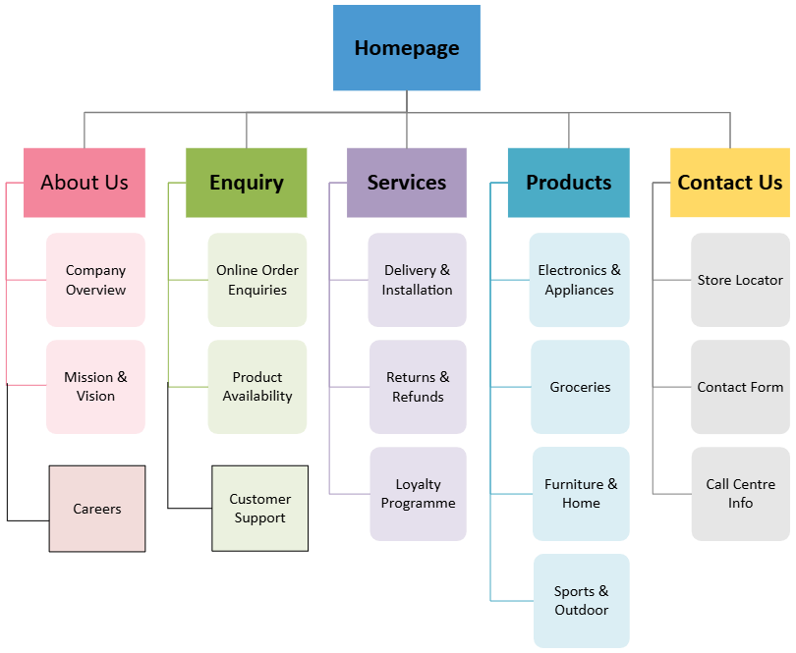

# 9. References:

* BigCommerce (n.d.) *How to Write a Website Proposal for Ecommerce*. [online] Available at: <https://www.bigcommerce.com/glossary/website-proposal/>[Accessed 14 Aug. 2025].
* Game (2025) *About Us*. [online] Available at: <https://www.game.co.za/game-za/en/store-finder/about-us> [Accessed 14 Aug. 2025].
* Massmart (2025) *Our Businesses*. [online] Available at: <https://www.massmart.co.za/our-businesses/game/> [Accessed 14 Aug. 2025].
* Shopify (2025) *How to Write a Retail Store Business Plan (+ Examples)*. [online] Available at: <https://www.shopify.com/za/retail/retail-store-business-plan> [Accessed 14 Aug. 2025].